Advanced Mobile Development - Project README

Contents

Introduction 1

Features 2

Internationalization 2

Feature 1 – Chat Rooms 2

Feature 2 – Blog Posts via Firebase 4

Additional features 6

Testing 8

User Requirements 8

Links 8

Play Store Description 8

App Title 8

Short Description 8

Full Description 8

Chat Rooms 8

Blogging 10

Additional features 11

Registration and Login 11

Internationalization 12

# Introduction

The idea behind this app is provide a service that allows people to communicate over text using Google Cloud Messaging as well as allowing the user share blog posts with other users. The app will be available in several different languages such as French, German and Spanish. Both main features in this app use google firebase in there functionality.

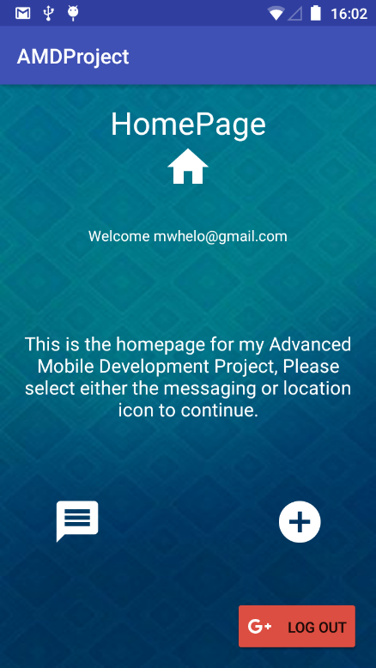

# Features

## Internationalization

This app supports 3 different languages other than English. These languages are:

* German
* Spanish
* French

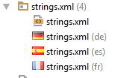

The way this feature works is as above there is a strings.xml file for each of the languages the app supports. Each file holds the string resources for all text in the app. Each of the files has these string resources in that specific language. When the user changes their language to one of the supported languages in their main phone settings, all text in the app will be in the correct language. These strings were translated using google translate.

## Feature 1 – Chat Rooms

This feature provides Google Cloud Messaging services to the user. This feature allows the user to communicate anonymously with other users if they choose to do so. The user can create “chat rooms” which any other user can enter and join in the conversation. When entering, the chat room the user is prompted to enter a name. The app does not display the email address the user used to sign into the app to other users, this is intentional. The reason for this is so that the user can decide whether they want to talk to other users using an alias or their real name.

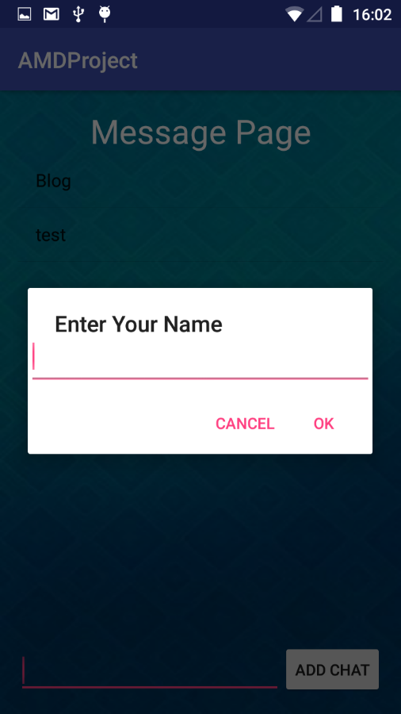

Once the user enters a name they’re taken to a landing page with a list of chat rooms created by other users. The title of the chat rooms related to the topic of conversation inside them.

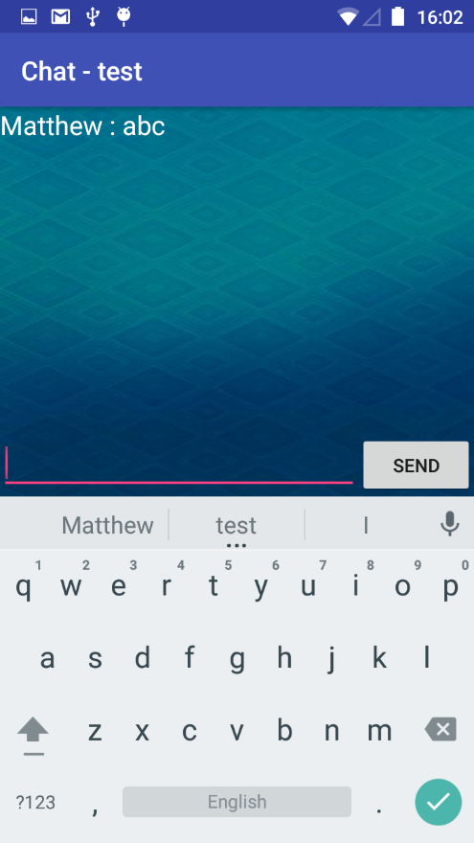

The name the user enters appears beside the message they post in the chat room. The messages are saved to a firebase database and appear in the console as per the screenshot below.

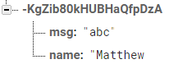

This is pushed to database through the following lines of code:

map2.put(**"name"**,**user_name**);  
map2.put(**"msg"**,**input_msg**.getText().toString());

## Feature 2 – Blog Posts via Firebase

The idea behind this feature was to allow users to post to real-time data feed to share anything that comes to mind with other users. The feed is updated instantly once the user hits the submit button. This feature differs from the chat room feature in terms of the disclosure of the user’s information. The users email address will be displayed on each the blog posts they make. The reason for this is so other users know where this information is coming from and decide whether to believe it or not based their opinion of the poster.

The app creates 3 different directories in the database to store the data submitted by the user. The code below shows how the app creates a directory for the blog post, the user who submits the blog and the likes the blog post gets from other users.

database = FirebaseDatabase.*getInstance*().getReference().child(**"Blog"**);  
**databaseUsers** = FirebaseDatabase.*getInstance*().getReference().child(**"Users"**);  
**databaseLikes** = FirebaseDatabase.*getInstance*().getReference().child(**"Likes"**);

Users can post a picture, a title and a description on every blog post. As per the screenshot below:

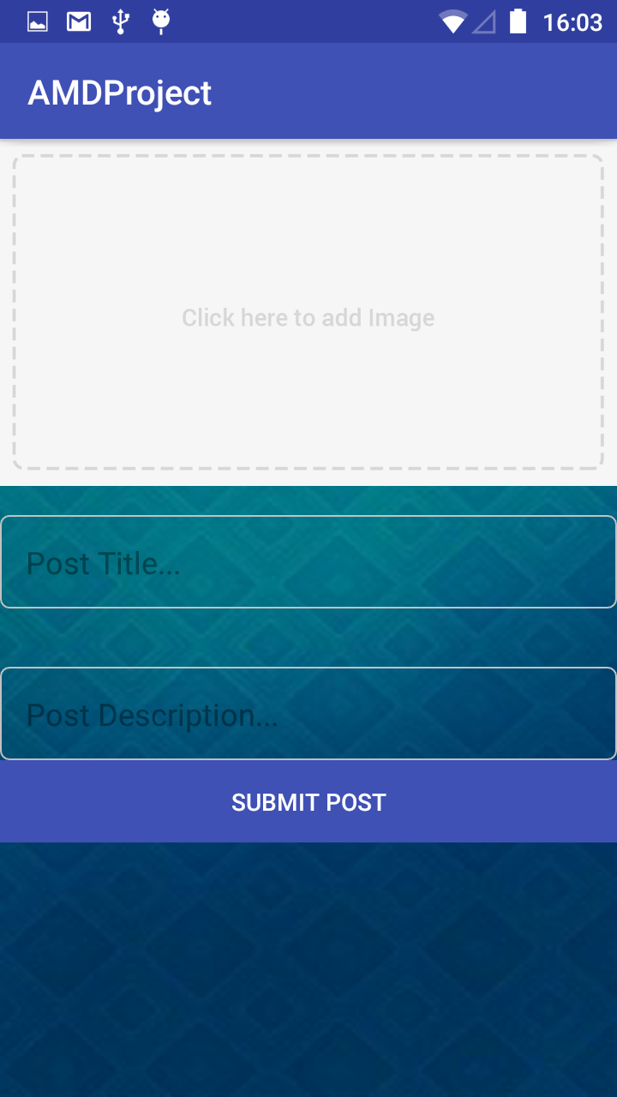

Once submitted the blog post will look like the screenshot below:

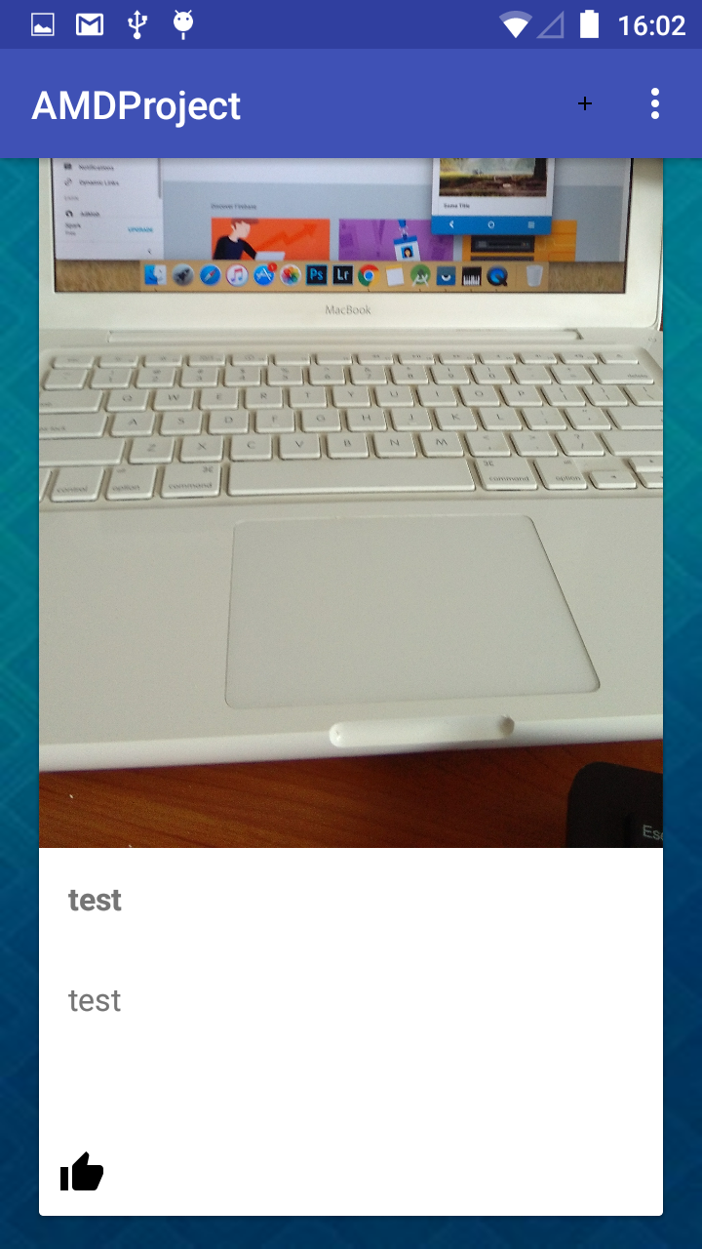

## Additional features

To access the app a user must register via their email address. This authentication is carried out on google firebase.

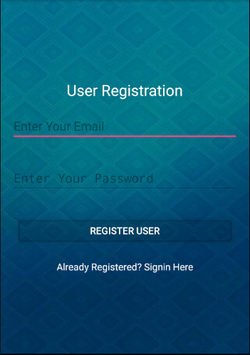

In order to access the app, the user has to register with their email address and also enter a unique password.

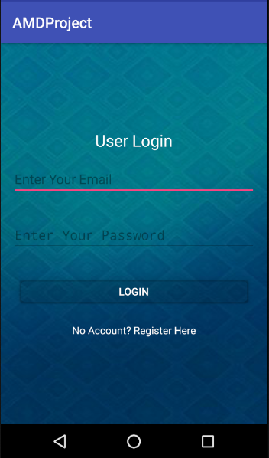

If the user has already registered, they will be greeted with the User Login page. Once the user enters their email and password, they will be brought to the homepage after they hit the login button.

# Testing

Testing of this app took place before and after the development of the app itself. Firstly, we had to get some user requirements and user profiles.

## User Requirements

### Site/User Requirement One – Efficiency

For the app to be successful, its efficiency is critical in order for the site to compete with its competitors in a crowded market. The user should be able to arrive at the homepage and immediately be able to start using the apps features once the user has been logged in.

In an already crowded market efficiency is key to success, if 10 different apps offer the same features, the app with the most efficient features will grow its reputation within the industry.

### Site/User Requirement Two – Data Availability

This requirement refers to how the app’s data should be available to the user at all times. If the user can’t access blog post or the chat rooms they’ve created whenever they want, they will start looking for other apps that can offer a better standard of data availability.

### Site/User Requirement Three – Internationality

With so many people across the world using chat apps to communicate with others internationality. With this in mind, the app is available in 4 different languages including English, German, Spanish and French.

## User Scenarios and Testing.

### User 1

Male. Aged 24. Experience with chat and blog apps.

### User 2

Female. Aged 23. Experience with chat and blog apps.

### Scenario 1

* Register with the App and access the homepage.
* Enter the chat feature.
* Create a chat room about any topic.
* Interact with other users on the app about this topic.

### User tasks

* Download the app.
* Register with the app.
* Carry out scenario.

### Scenario 2

* Register with the app and access the homepage.
* Enter the blog feature.
* Click the plus button at the top right of the app.
* Fill out the required information to make a blog post.
* Interact with other user’s blog posts.

### User tasks

* Download the app.
* Register with the app.
* Carry out scenario.

# Links

DropBox - <https://www.dropbox.com/s/mt81jj7errqxgqg/AdvancedMobileDevProject-master.zip?dl=0>

Github - <https://github.com/mwhelo/AMDProject>

# Play Store Description

## App Title

Chatter

## Short Description

Chatter is a social mobile app that delivers real time date integration using google firebase.

Feature one delivers a real time messaging feature to the user. The user can use this feature anonymously or as themselves, to create chat rooms about topics they’re interested in to talk to other users.

The second feature delivers a blogging feature to the users. The user can post a picture with a title and description for other users to like and interact with.

## Full Description

## Chat Rooms

This feature provides Google Cloud Messaging services to the user. This feature allows the user to communicate anonymously with other users if they choose to do so. The user can create “chat rooms” which any other user can enter and join in the conversation. When entering, the chat room the user is prompted to enter a name. The app does not display the email address the user used to sign into the app to other users, this is intentional. The reason for this is so that the user can decide whether they want to talk to other users using an alias or their real name.



Once the user enters a name they’re taken to a landing page with a list of chat rooms created by other users. The title of the chat rooms related to the topic of conversation inside them.



The name the user enters appears beside the message they post in the chat room.

## Blogging

The idea behind this feature was to allow users to post to real-time data feed to share anything that comes to mind with other users. The feed is updated instantly once the user hits the submit button. This feature differs from the chat room feature in terms of the disclosure of the user’s information. The users email address will be displayed on each the blog posts they make. The reason for this is so other users know where this information is coming from and decide whether to believe it or not based their opinion of the poster.

Users can post a picture, a title and a description on every blog post. As per the screenshot below:



Once submitted the blog post will look like the screenshot below:



## Additional features

### Registration and Login

To access the app the user must use their email and a unique password. This information is authenticated by google firebase’s authentication service.





### Internationalization

The app supports four different languages English, German, Spanish and French. The language of the app changes depending on main language settings on the user’s phone.